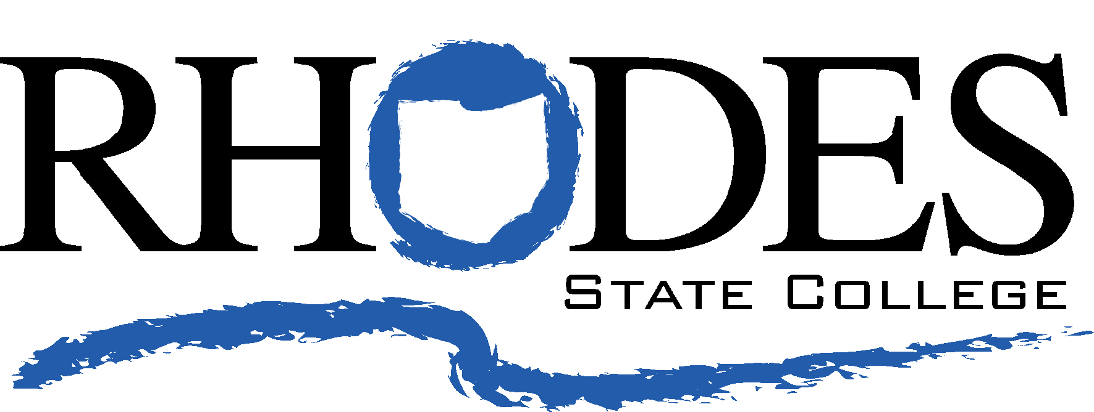

Workforce Development & Innovation (WDI) Service Contract
Rhodes State College • 179 James J. Countryman Building • 4240 Campus Drive • Lima, OH 45804

Client Information: Name

Deliverables: Hospital Nurse Aide Training Program
- On-line 30-hour training per student provided by RSC
- Books to be provided by Hospital
- Skills Assessments to be conducted by Hospital

Project Duration: June 19, 2023 and continuing until both parties agree to terminate.

Project Cost: $225 per student

Payment Terms: Hospital will be billed on a monthly basis for the
number of students registered for the training. Payment by purchase order
is to be made to:
Rhodes State College
4240 Campus Drive
Lima, Ohio 45804

Amendment of Agreement: Any changes to this contract must be signed by representatives of Hospital and Rhodes State College in order for the change to be valid. Rhodes State reserves the right for either party to terminate this contract at any time. A minimum notice of 15 days in writing must be provided to terminate this agreement. Hospital is responsible for only costs incurred for introductions and training delivered.

WDI Contact: Name
Workforce Development & Innovation
Rhodes State College
4240 Campus Drive
Lima, Ohio 45804-3597
Phone

Billing-Related: Contact Name
Phone
Email

A signature is required to authenticate this agreement.

Contract Accepted by: Date

Printed Name: Date

Name Date
Senior Director, WDI
Rhodes State College

